NAME:R. BOOSHAN

REG.NO:192110139

DAY -2 [DWDM]

1)DIVISION:

A=10

B=2

C=A/B

PRINT(C)



2) Histogram:

temperatures <- c(20, 22, 25, 29, 23, 27, 28)

result <- hist(temperatures, main = "Maximum Temperatures in a Week",

xlab = "Degree Celsius",

ylab = "Day",

names.arg = c("Sun", "Mon", "Tue", "Wed", "Thu", "Fri", "Sat"),

col="green" )

print(result)

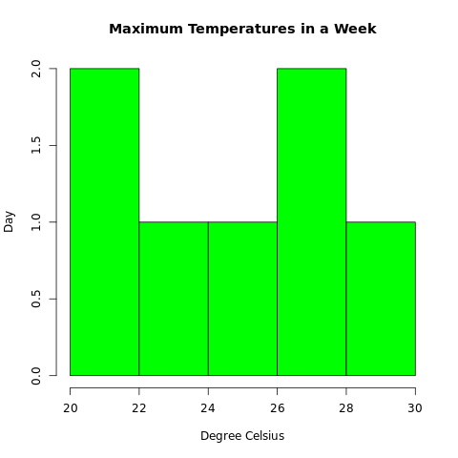

3) Linear regression:

x <- c(150, 174, 138, 186, 128, 136, 171, 163, 152, 131)

y <- c(63, 81, 56, 91, 47, 57, 76, 72, 62, 48)

relation <- lm(y ~ x)

print(summary(relation))

a <- data.frame(x = 170)

result <- predict(relation, a)

print(result)

png(file = "linear_regression.png")

plot(y, x, col = "red", main = "Height and Weight Regression", abline(lm(x ~ y)), cex = 1.3, pch = 16, xlab = "Weight in Kg", ylab = "Height in cm")

dev.off()



4) Median:

height <-c(150,174, 138, 186, 128, 136, 171, 163, 152, 131)

result.median <-median(height)

print(result.median)



5) Min max normalization:

original_vector <- c(10, 20, 30, 40, 50)

normalized_vector<-(original_vector- min(original_vector)) / (max(original_vector)

- min(original_vector))

print(normalized_vector)

original_vector <- c(100, 200, 309, 40, 50,60,70,80,90,10)

normalized_vector<-(original_vector- min(original_vector)) / (max(original_vector)

- min(original_vector))

print(normalized_vector)

